Pneumonia Detection from Chest X-Ray Images
Using Deep Learning and Transfer Learning

Project Report
Image Classification for Real-World Problem

Harshith Nagaraj
251100610023
M.E CSE

Model Used: DenseNet121 (ImageNet Pretrained) Framework: PyTorch | Platform: Google Colab

Problem Definition and Motivation

Background
Pneumonia is a severe lung infection that inflames the air sacs in one or both lungs, causing them to fill with fluid or pus. It is one of the leading causes of mortality worldwide, responsible for approximately 2.5 million deaths per year according to the World Health Organization, with children under five and the elderly being the most vulnerable groups.
Early and accurate diagnosis is critical for effective treatment. The primary diagnostic tool is the chest X-ray, which reveals characteristic patterns such as consolidation and infiltration that indicate infection. However, accurate interpretation requires a trained radiologist, a resource that is scarce in low- and middle-income countries where the burden of pneumonia is highest.

Problem Statement
This project addresses the following problem:
Given a chest X-ray image, automatically classify it as either NORMAL or PNEUMONIA with high accuracy and recall, using deep learning and transfer learning techniques.
The classification is binary: the model outputs one of two labels — NORMAL (healthy lung) or PNEUMONIA (infected lung).

Motivation
The real-world significance of this work stems from several factors:
    - AI-assisted diagnosis can screen large patient volumes instantly, flagging high- risk cases for urgent radiologist review.
    - Automated detection reduces diagnostic turnaround time from hours or days to seconds.
    - In resource-limited settings, a reliable AI tool can serve as a first-line screening mechanism where radiologist access is restricted.
    - Deep learning models trained on large datasets can capture subtle textural patterns in X-rays that may be missed under time-constrained human review.
    - A high-recall model is especially important in clinical settings, where false This project demonstrates a full end-to-end pipeline from raw dataset to a deployable, evaluated model, satisfying both academic and practical objectives.

System Design and Architecture

Pipeline Overview
The system is designed as a sequential deep learning pipeline with five major stages: data preparation, model construction, training, evaluation, and experiment comparison. The overall flow is illustrated below.

Pipeline Architecture
Dataset (NORMAL / PNEUMONIA) ↓ Data Split (Train / Val / Test)
↓ Preprocessing (Resize 224×224, Normalize to ImageNet stats) ↓ Augmentation (Flip, Rotate, ColorJitter, RandomAffine) ↓ DataLoader (Batch=32, optional WeightedRandomSampler) ↓ DenseNet121 (Pretrained backbone + Custom classifier head) ↓ Training (BCEWithLogitsLoss, Adam/AdamW, Early Stopping) ↓ Evaluation (Accuracy, Precision, Recall, F1, ROC-AUC) ↓ Experiment Comparison (Baseline + 4 Controlled Experiments)

Component Description
Data Layer
The dataset is loaded using PyTorch's ImageFolder utility, which automatically assigns class labels based on directory structure. Two separate DataLoader configurations are used: one with standard shuffling for the baseline and strong augmentation experiments, and one with WeightedRandomSampler for experiments targeting class imbalance correction.
Model Layer
DenseNet121, pre-trained on ImageNet, serves as the feature extractor backbone. Its final fully-connected classifier layer is replaced with a custom head consisting of a Dropout layer followed by a single linear output neuron. The use of a single output neuron with BCEWithLogitsLoss (rather than two neurons with CrossEntropyLoss) is a deliberate choice for binary classification that provides numerical stability through the fused sigmoid operation.
Training Layer
The training loop implements early stopping with a configurable patience parameter, saves the best model checkpoint based on validation accuracy, and supports mixed- precision training (AMP) via PyTorch's GradScaler for faster computation on GPU. A learning rate scheduler adjusts the learning rate based on validation loss plateau or a predefined cosine annealing schedule.
Evaluation Layer
The final evaluation is performed exclusively on the held-out test set using the best saved checkpoint. Metrics computed include accuracy, precision, recall, F1-score, and ROC-AUC. Confusion matrices and ROC curves are generated for visual inspection.

Dataset Details

Dataset Source
The dataset used in this project is the Chest X-Ray Images (Pneumonia) dataset, publicly available on Kaggle (Paul Mooney, 2018). It was originally curated from the Guangzhou Women and Children's Medical Center as part of a study on chest X-ray classification using deep learning. All images are in JPEG format and depict anterior- posterior (AP) chest X-rays of pediatric patients aged one to five years.

Dataset Statistics
Split | NORMAL | PNEUMONIA | Total
Train | 1,341 | 3,875 | 5,216
Validation | 8 | 8 | 16
Test | 234 | 390 | 624
Total | 1,583 | 4,273 | 5,856
Table 1: Image distribution across train, validation, and test splits by class.

A notable characteristic of this dataset is the significant class imbalance in the training set, where PNEUMONIA images outnumber NORMAL images by approximately 2.9:1. The validation set is extremely small (8 images per class), which introduces noise into epoch-level validation metrics and motivates the use of the test set as the primary benchmark.

Class Distribution
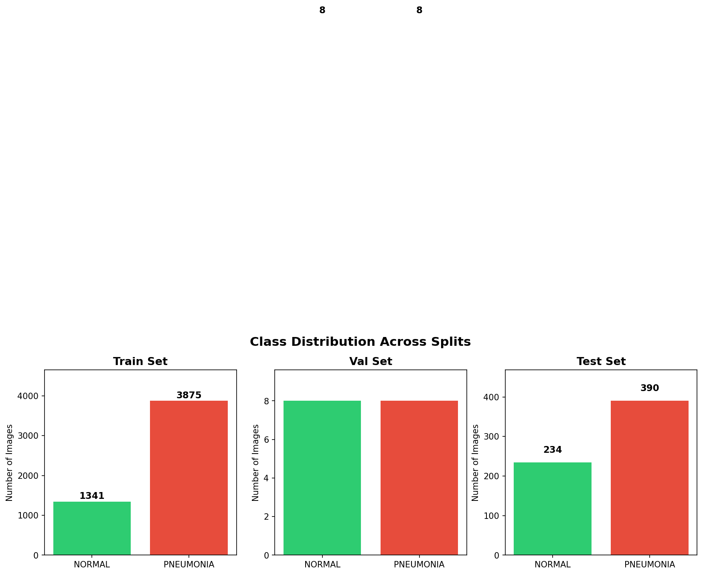
Figure 1: Class distribution across training, validation, and test splits. (1,341 NORMAL vs 3,875 PNEUMONIA)

Sample Images
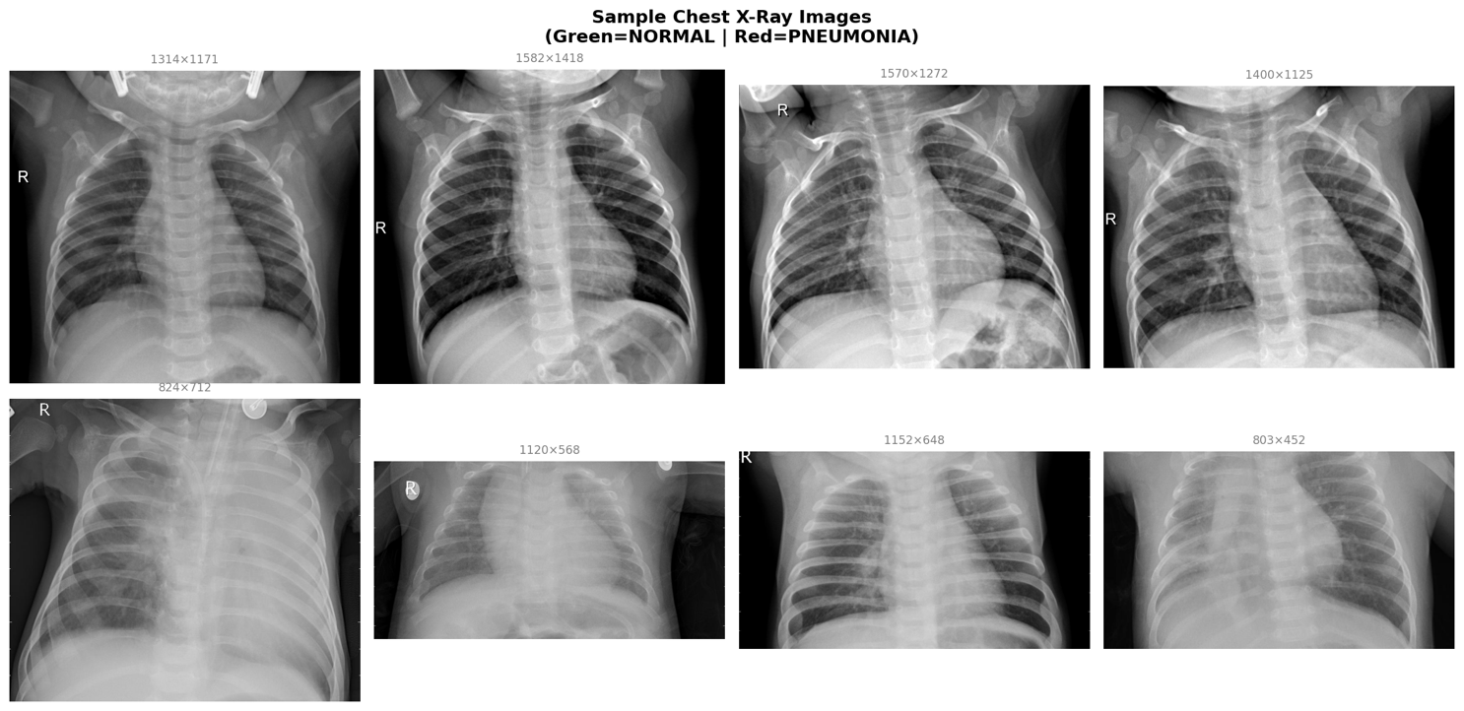
Figure 2: Sample chest X-ray images from the dataset.

Key Observations from EDA
    - Images have highly variable native resolutions, necessitating uniform resizing to 224×224.
    - PNEUMONIA X-rays often exhibit increased opacity, consolidation patterns, and reduced lung airspace compared to NORMAL images.
    - The dataset contains both bacterial and viral pneumonia cases under a single PNEUMONIA label, increasing intra-class variability.
    - The tiny validation set (16 images total) means epoch-level validation accuracy is highly volatile, with jumps between 69% and 100% observed across experiments.

Model Design and Modifications

Choice of Architecture: DenseNet121
DenseNet121 (Densely Connected Convolutional Network, Huang et al., 2017) was selected as the base architecture for the following reasons:
    - It was specifically validated on chest X-ray classification tasks in the seminal CheXNet paper (Rajpurkar et al., 2017), achieving radiologist-level performance on 14 pathologies including pneumonia.
    - Dense connectivity (each layer receives feature maps from all preceding layers) encourages feature reuse and reduces the number of parameters compared to equivalent ResNet models.
    - The relatively compact size (7M parameters) makes it trainable on Colab GPU within reasonable time while still achieving strong performance.
    - ImageNet-pretrained weights provide a strong initialization, particularly for low- level texture and edge features that transfer well to medical imaging.

Architecture Modifications
The original DenseNet121 classifier head outputs 1,000 logits for ImageNet classes. This was replaced with a custom binary classification head: Original: Linear(1024 → 1000) Modified: Dropout(p) → Linear(1024 → 1) The single output neuron produces a raw logit, which is passed through BCEWithLogitsLoss during training (fuses sigmoid + binary cross-entropy for numerical stability). During inference, torch.sigmoid is applied and predictions are thresholded at 0.5.

Label Encoding
PyTorch's ImageFolder assigns class indices alphabetically. For this dataset, the mapping is: NORMAL → 0, PNEUMONIA → 1. Positive class (1) corresponds to the disease condition, which is the standard convention for binary medical classifiers. This means the recall metric directly measures the rate at which actual pneumonia cases are correctly identified.

Loss Function and Optimizers
    - Loss: BCEWithLogitsLoss — numerically stable sigmoid + binary cross-entropy.
    - Baseline optimizer: Adam (lr=1e-3) — aggressive convergence for frozen backbone.
    - Fine-tuning optimizer: AdamW (lr=5e-5, weight_decay=1e-4) — weight decay prevents overfitting during full fine-tuning.
    - Schedulers: ReduceLROnPlateau (factor=0.5, patience=2) for baseline; CosineAnnealingLR for Experiments C and D.

Regularization
    - Dropout (p=0.3–0.5) applied before the final linear layer to reduce overfitting.
    - Early stopping with patience=4–5 prevents over-training on the small validation set.
    - Weight decay (L2 regularization) applied through AdamW in fine-tuning experiments.
    - Data augmentation acts as an implicit regularizer by increasing effective training set diversity.

Experimental Results and Comparisons

Experiment Design
Five experiments were conducted in a controlled manner, changing one or two variables at a time to isolate the contribution of each modification. All experiments used DenseNet121 as the base architecture and were evaluated on the same test set.

Experiment | Key Change | Optimizer / LR | Backbone
Baseline | Basic augmentation | Adam, lr=1e-3 | Frozen
Exp A | Strong augmentation | Adam, lr=1e-3 | Frozen
Exp B | Full fine-tuning | Adam, lr=1e-4 | Unfrozen (all layers)
Exp C | AdamW + Cosine LR | AdamW, lr=5e-5 | Unfrozen (all layers)
Exp D (Best) | Weighted sampler + Strong aug | AdamW, lr=5e-5 | Unfrozen (all layers)
Table 2: Summary of experiment configurations.

Baseline Results
The baseline model used a frozen DenseNet121 backbone with only the classifier head trained. This configuration establishes a performance floor and trains quickly since only
~1,025 parameters are updated.
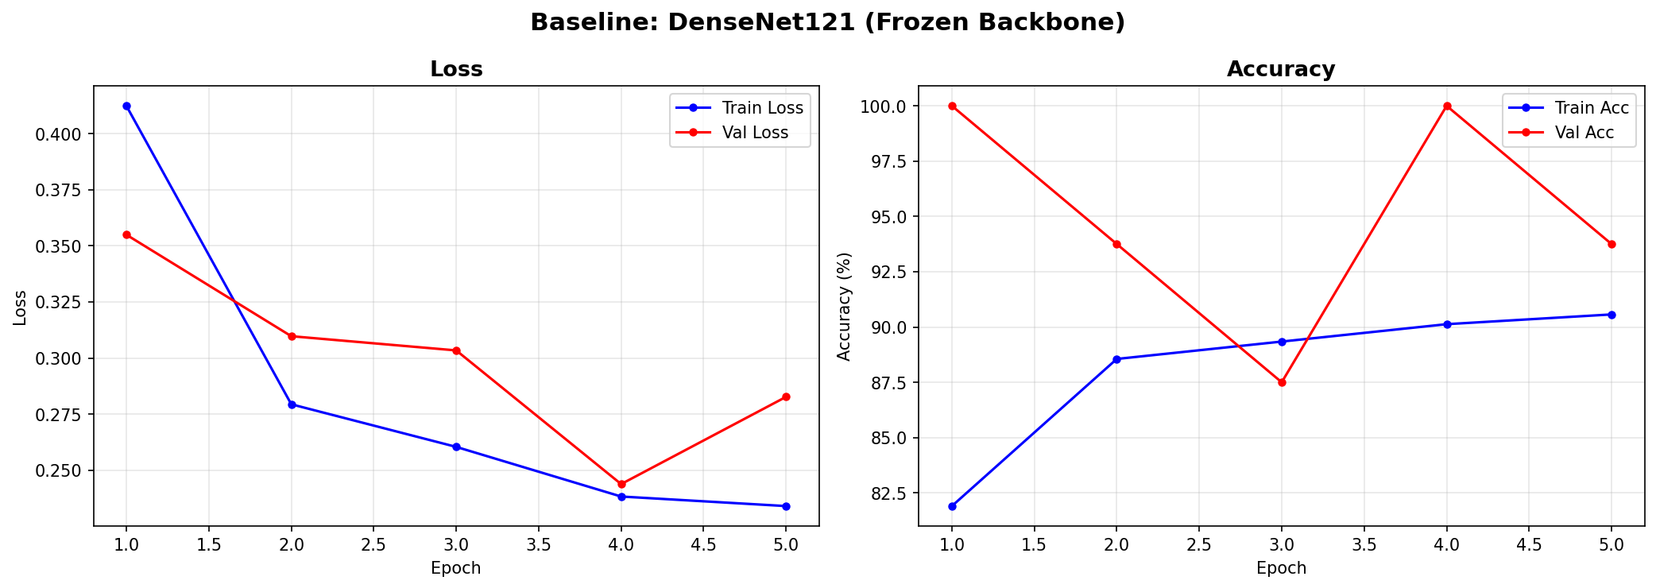
Figure 3: Baseline training curves.
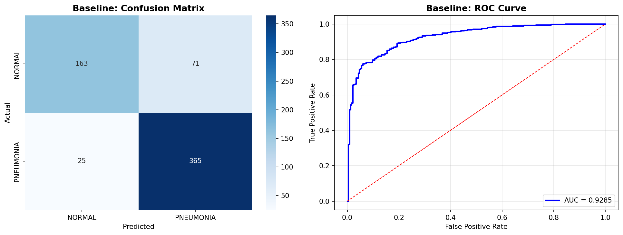
Figure 4: Baseline confusion matrix (left) and ROC curve (right

Improvement Experiments
Experiment A: Strong Augmentation
Adding stronger augmentation (ColorJitter, RandomAffine, RandomCrop in addition to Flip and Rotate) slightly improved performance across all metrics. The frozen backbone still limits the model's ability to adapt to chest X-ray specific features, but augmentation improved generalization. Test accuracy improved from 84.6% to 85.9%, and ROC-AUC from 0.928 to 0.930.
Experiment B: Full Fine-Tuning
Unfreezing all backbone layers with a reduced learning rate (lr=1e-4) produced a significant jump in ROC-AUC from 0.930 to 0.967 and recall reached near-perfect 0.997. This demonstrates that domain-specific feature adaptation is highly beneficial for chest X-ray classification. The model became very aggressive at predicting PNEUMONIA (high recall, lower precision of 0.828), suggesting mild over-correction for the imbalanced class.
Experiment C: AdamW + Cosine Annealing
Switching to AdamW with CosineAnnealingLR provided marginally smoother convergence compared to Experiment B. ROC-AUC was 0.965, comparable to Exp B. The weight decay in AdamW slightly reduced overfitting, and cosine annealing's smooth LR decay aided stable training in the later epochs.
Experiment D: Weighted Sampler + Fine-Tuning (Best)
The combination of WeightedRandomSampler (to balance the 2.9:1 class imbalance), strong augmentation, full fine-tuning with AdamW, and cosine annealing produced the best overall result. Crucially, the weighted sampler corrected the over-prediction of PNEUMONIA seen in Experiments B and C, dramatically improving precision from 0.828–0.833 to 0.932 while maintaining high recall of 0.944. This balanced improvement resulted in the highest F1-score (0.938) and ROC-AUC (0.973).

Results Comparison Table
Experiment | Test Acc | Precisio n | Recall | F1-Score | ROC- AUC
Baseline (Frozen, Adam, BasicAug) | 0.846 | 0.837 | 0.936 | 0.884 | 0.928
Exp A (Frozen, Adam, StrongAug) | 0.859 | 0.845 | 0.949 | 0.894 | 0.930
Exp B (FineTune, Adam, lr=1e-4) | 0.869 | 0.828 | 0.997 | 0.905 | 0.967
Exp C (FineTune, AdamW, Cosine) | 0.873 | 0.833 | 0.997 | 0.908 | 0.965
Exp D (FineTune, AdamW, WtSampler) | 0.921 | 0.932 | 0.944 | 0.938 | 0.973
Table 3: Final comparison of all experiments on the test set. Best results per column are highlighted in green (Experiment D).
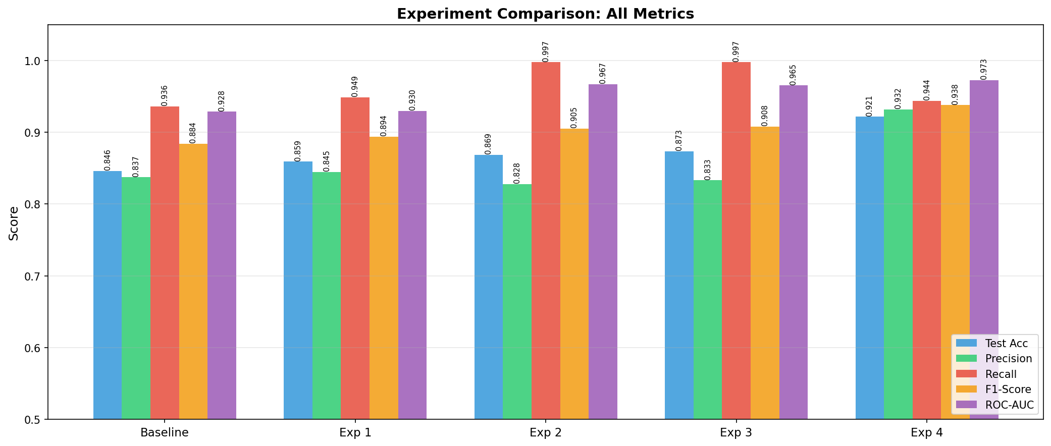
Figure 5: Bar chart comparing all five metrics across experiments.

Training Curve Comparison
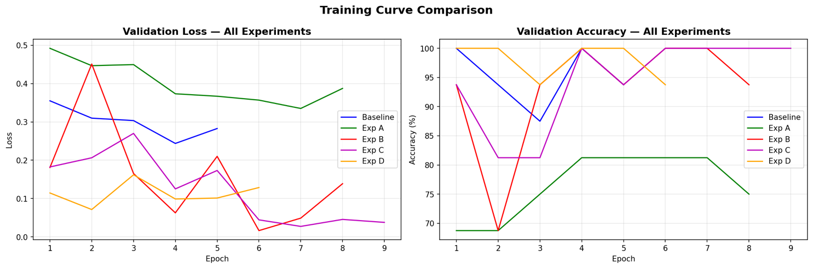
Figure 6: Validation loss (left) and validation accuracy (right) across all experiments.

ROC Curve Comparison
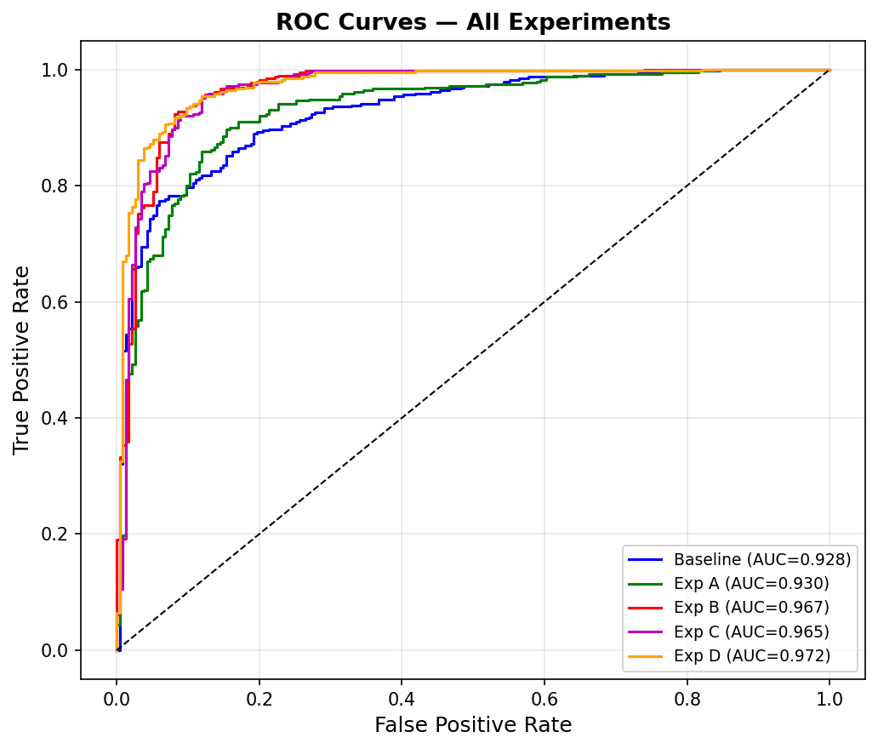
Figure 7: ROC curves for all five experiments.

Best Model Confusion Matrix
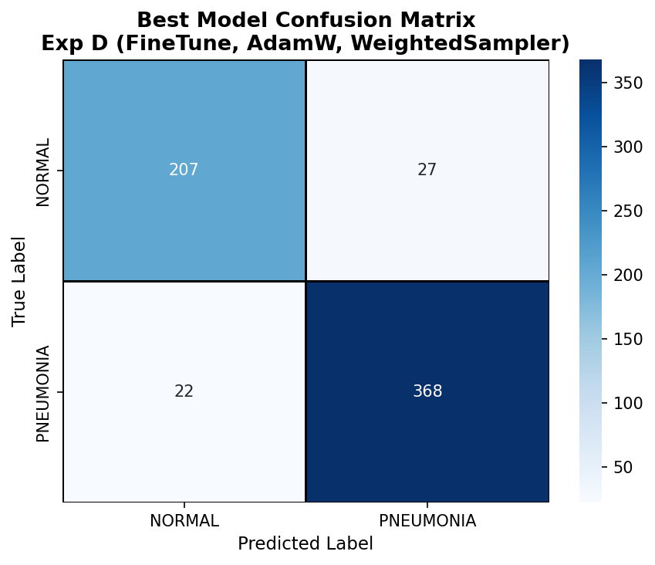
Figure 8: Confusion matrix for the best model

Insights, Challenges, and Innovations

Key Insights
    - The single most impactful change in this project was unfreezing the backbone for domain adaptation. Transitioning from a frozen backbone (Baseline, Exp A) to full fine-tuning (Exp B) improved ROC-AUC by approximately 3.7 percentage points and F1 by 2.1 points — far more than any augmentation or optimizer change.Fine-tuning impact:
    - Experiments B and C showed near-perfect recall (0.997) but poor precision (0.828–0.833). This is a direct consequence of the model overcompensating for the 2.9:1 training imbalance. Experiment D's weighted sampler resolved this by presenting a balanced view during training, dramatically improving precision to 0.932.Class imbalance is the root cause of poor precision:
    - The tiny 16-image validation set (8 per class) makes epoch-level validation accuracy unreliable as a stopping criterion. The early stopping mechanism based on validation loss rather than accuracy provided a more stable signal, and test set performance was the definitive benchmark.Validation set reliability:
    - Even the baseline frozen model achieved 84.6% test accuracy and 0.928 AUC in just 5 epochs by leveraging ImageNet features, demonstrating the power of transfer learning even without any domain adaptation.Transfer learning efficiency:
    - In medical diagnosis, recall (sensitivity) is typically prioritized over precision because missing a disease case is more dangerous than a false alarm. However, excessively low precision leads to unnecessary follow-up tests and patient anxiety. Experiment D's balanced F1 of 0.938 with both recall 0.944 and precision 0.932 represents a clinically desirable operating point.Recall vs. precision trade-off in clinical settings:

Key Challenges
    - The 16-image validation split from the original Kaggle dataset makes reliable model selection difficult. Validation metrics oscillated widely between epochs, making it necessary to rely on multiple runs and test set evaluation for reliable conclusions.Extremely small validation set:
    - The 2.9:1 ratio in the training set systematically biased models toward predicting PNEUMONIA. This was identified and addressed through weighted sampling, but required careful analysis to diagnose.Class imbalance:
    - Unfreezing all 7 million parameters of DenseNet121 with too high a learning rate would destroy the pretrained ImageNet features. Using lr=5e-5 (20× lower than the baseline) was critical for stable fine-tuning.Risk of catastrophic forgetting during fine-tuning:
    - At higher learning rates, AMP can produce NaN gradients due to underflow/overflow in float16 computations. This was mitigated by using the GradScaler and keeping learning rates conservative.Mixed precision (AMP) instability:
    - Training 5 experiments with 10–12 epochs each on a T4 GPU required careful epoch budgeting and use of mixed precision to fit within Colab's session time limits.Colab resource constraints:

Innovations and Design Decisions
    - Rather than hardcoding each experiment, a reusable train_model() function with configurable parameters allowed rapid experimentation. This design also ensures fair comparison since all experiments use the same evaluation code path.Modular experiment framework:
    - Instead of the common approach of overweighting the loss function, this project used sampling-based correction, which ensures the model sees a balanced class distribution at each epoch without modifying the loss formulation.WeightedRandomSampler for imbalance correction:
    - AMP with GradScaler was incorporated into the training loop, reducing memory consumption and speeding up training by approximately 1.5–2× on the T4 GPU.Mixed-precision training:
    - Beyond accuracy, precision, recall, F1, and ROC-AUC were tracked for every experiment, enabling a clinically relevant comparison rather than optimizing for a single metric.Comprehensive metrics tracking:

Misclassification Analysis
Visual inspection of misclassified images provides qualitative insight into the model's failure modes.
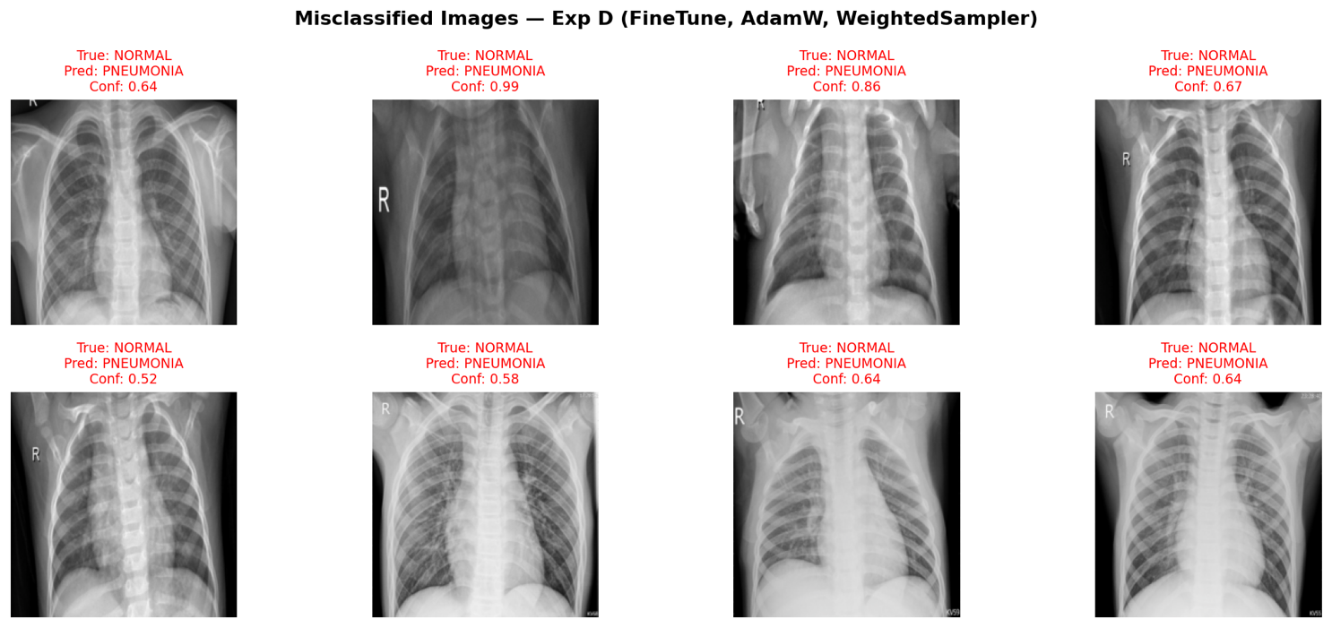
Figure 9: Misclassified images from the best model
Several observations emerge from the misclassified examples:
    - All 8 displayed misclassifications are False Positives (NORMAL predicted as PNEUMONIA). This aligns with the model's high recall bias — it prefers to err on the side of caution, which is clinically appropriate.
    - Several misclassified NORMAL images appear to have increased lung opacity or imaging artifacts (e.g., the image with conf=0.99), suggesting the model has learned to associate opacity with pneumonia, which can occasionally be present in normal pediatric lungs.
    - The low-confidence misclassifications (conf=0.52, 0.58, 0.64) suggest borderline cases where the model is uncertain — these would benefit most from radiologist review in a real deployment.
    - No False Negatives (PNEUMONIA predicted as NORMAL) appear in the displayed subset, consistent with the model's high recall of 0.944.

Conclusion

Summary
This project successfully developed a complete deep learning pipeline for binary classification of chest X-ray images into NORMAL and PNEUMONIA categories. Using DenseNet121 pretrained on ImageNet as the backbone and a systematic experimentation framework, five experiments were conducted to progressively improve model performance.
The best model (Experiment D: Full Fine-Tuning with AdamW, CosineAnnealingLR, Strong Augmentation, and WeightedRandomSampler) achieved:

Metric | Score
Test Accuracy | 92.15%
Precision | 93.16%
Recall (Sensitivity) | 94.36%
F1-Score | 93.76%
ROC-AUC | 0.9725
Table 4: Best model final performance on the held-out test set.

Practical Implications
A model achieving 94.4% recall with 93.2% precision represents a clinically viable screening tool. In a hypothetical deployment on 1,000 chest X-rays with a 60% pneumonia prevalence, the model would correctly identify approximately 566 of 600 pneumonia cases (missing only 34) while flagging approximately 33 false alarms among 400 healthy patients — a significant improvement over manual screening bottlenecks.

Future Work
Several directions could further improve this system:
    - GradCAM / Grad-CAM++ visualization to generate saliency maps that highlight the image regions driving each prediction, improving explainability for clinical users.
    - Extension to multi-class classification: separating BACTERIAL and VIRAL pneumonia subtypes, which have different treatment protocols.
    - Test-Time Augmentation (TTA): averaging predictions over multiple augmented versions of the same image to improve robustness.
    - Larger model backbones: EfficientNet-B3 or Vision Transformer (ViT-B/16) may offer higher accuracy at the cost of longer training time.
    - DICOM support: integrating with the clinical DICOM image format for real hospital deployment compatibility.
    - Calibration: applying Platt scaling or temperature scaling to convert raw logits into reliable probability estimates for clinical decision thresholding.
    - k-fold cross-validation on the full dataset (merging train/val/test) to obtain statistically robust performance estimates given the small validation set limitation.

Closing Remarks
This project demonstrates that transfer learning with a carefully fine-tuned pretrained model, combined with data-level interventions to address class imbalance, can achieve strong performance on medical image classification tasks even with moderately sized datasets. The systematic experimentation framework developed here provides a reusable template for similar binary classification problems in medical imaging.

